INSTRUCTION MANUAL FOR DRY BATH DSD-100D & DSD-200D

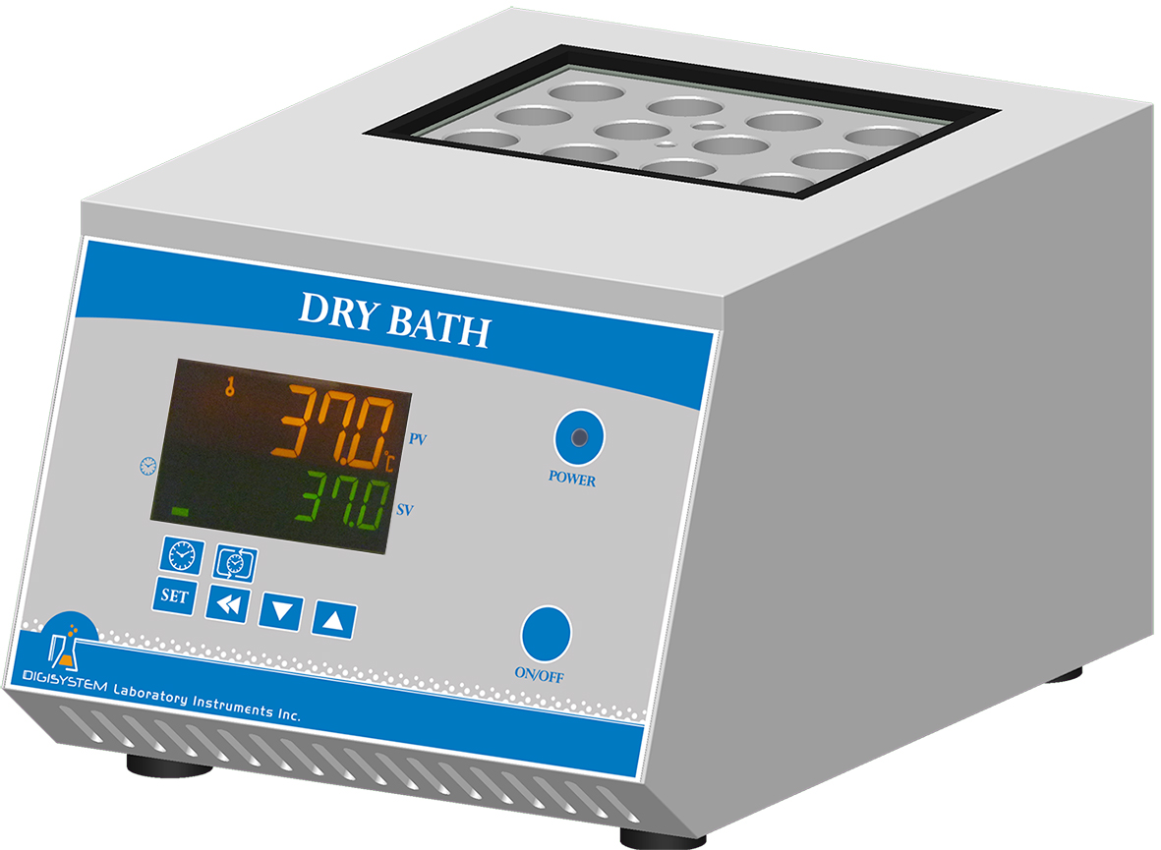
Block
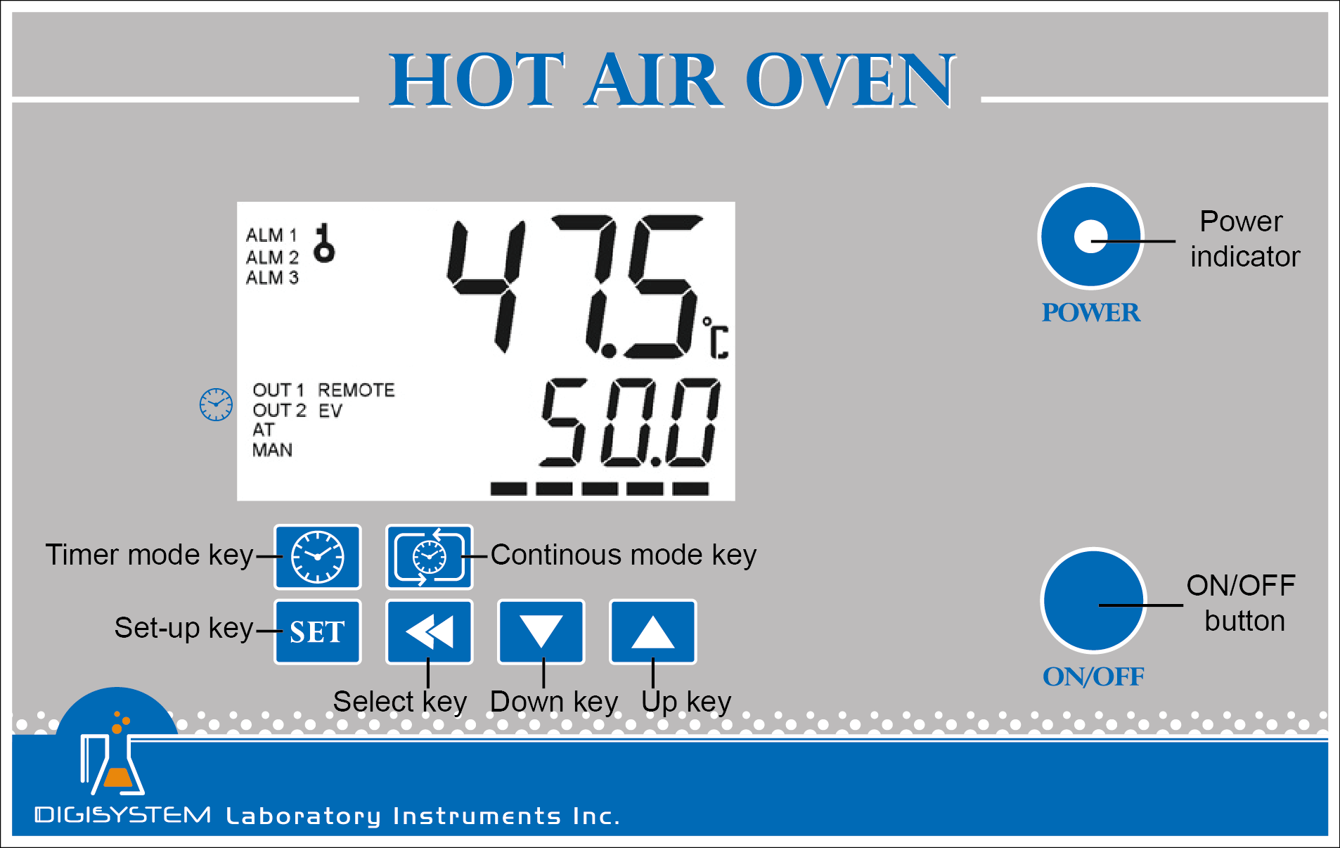

Block
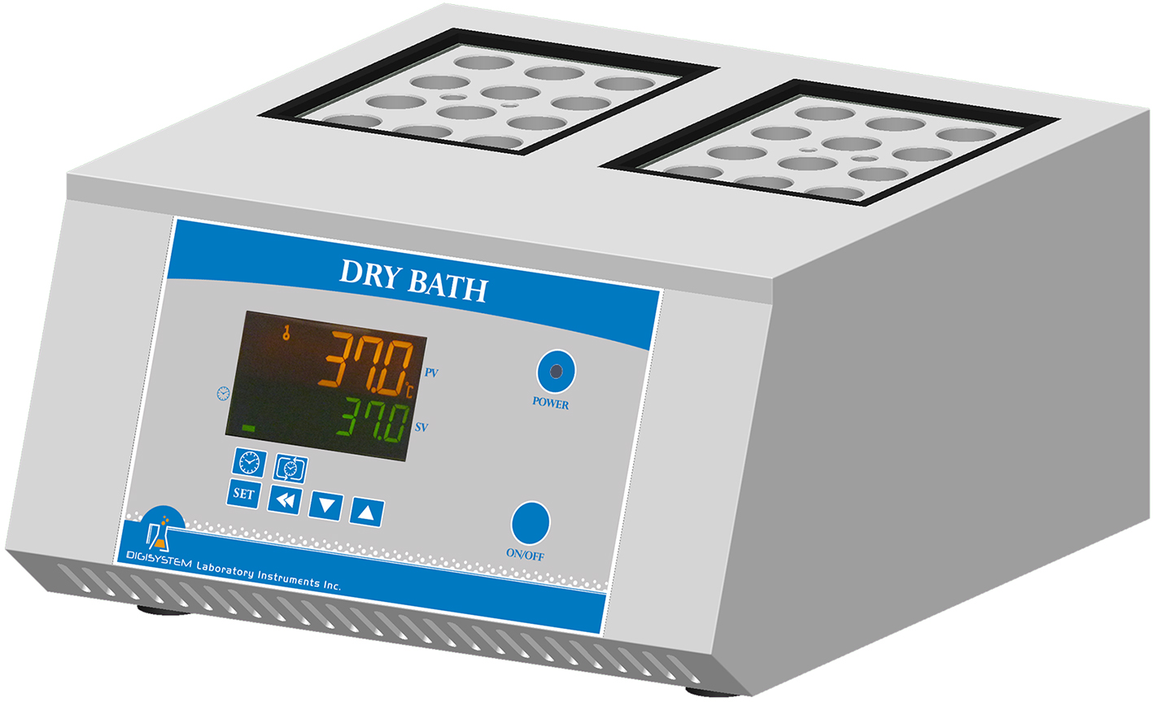

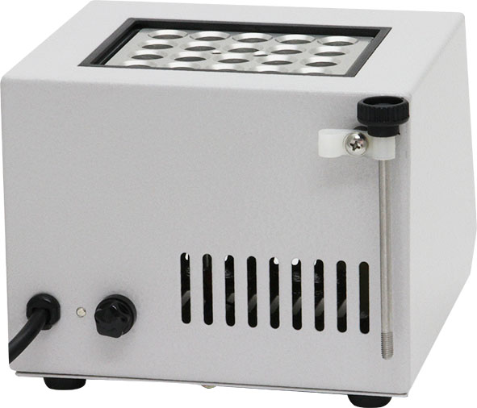
Block lifter

Warnings:
* The surface is hot. Do not touch.
* Do not put any objects on the top of the instrument.
* Please keep the environment ventilated.
* The instrument should be placed in a low relative humidity and low dust place away from water source.

1. Connect with power supply. Please make sure the power voltage is the same as the voltage shown on the label stuck on the back of machine.
2. Press “ON/OFF Button”, then you will see the “Power indicator’ becomes green. Wait for about 5 seconds; you can see that on the display screen, the top row is the present temperature value (PV) and the bottom row is the setting temperature value (SV).
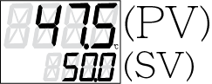


3. Set temperature: you will see . Press or to adjust SV value and then press to enter the value.



4. Set time: Select time mode: Continouos mode or Timer mode .

4.1 Press to set Continuous mode. OUT2 indicator on display screen will disappear. The setting is finished. Go to Step 6.

4.2 Press to set Timer mode. OUT2 indicator on screen will appear.
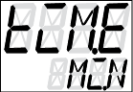
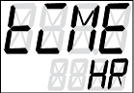
4.2.1 You will see or .

4.2.2 Use or key to select time unit  (hour) or  (minute). Press to enter the value. Press  to next setting.

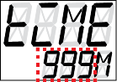
4.2.3 You will see . Use or key to adjust the time value. Press to enter the value. Press to next setting.
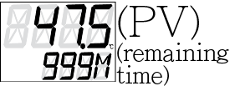
4.2.4 You will see . Press and you will see . The setting is finished.
Remark: If you want to interrupt the timer mode, you can press to be continuous mode.
5. After finishing the work, please press “ON/OFF Button” to turn off the power, and then the “Power indicator’ becomes red.

Remark:
When the “OUT1” indicator on the display screen is sparkling, it means that the instrument is heating.
Caution:
In any of following causes, turn off the power supply and unplug immediately. And contact the distributor for service.
- Liquid drops into the instrument.
- The instrument is dropped or the housing is damaged.
- The instrument works abnormally, especially generating an abnormal odor or sound.

Maintenance and care:
Keep the instrument clean all the time, so no routine maintenance is required. Cleaning can be done with a damp cloth. Avoid the use of solvents as they may damage the product housing and inner chamber. The holes of blocks should be regularly cleaned with a damp cloth to make sure that the test tube will be contracted with the wall of the holes so as to have good heat conduction. When cleaning the instrument, the power supply should be unplugged.

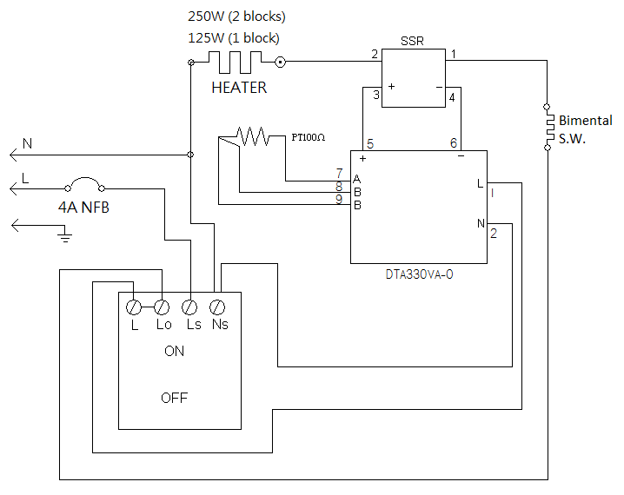
Circuit Diagram:

Other functions:
Note: Before executing other functions , please make sure that the continuous mode is selected.
If you see OUT2 indicator on the screen, please press to set Continouos mode.
- Other functions include PV shift (offset) value, setting alarm point, setting temperature unit, auto tuning function.
Action | Display  (Initial value) | Explanation | Adjustment
Press |   (0) | PV shift (offset) value. If PV value is not correct, you can use this function to calibrate by your own thermometer. | Press or to adjust the value. Then press to enter the value.  If you want to go back to PV/SV display, press again.
Press |   (4) | Upper-limit point for alarm. When the difference between PV and SV is over upper-limit, the alarm indicator (ALM1) on display screen will be flashing.
Press |   (4) | Lower-limit point for alarm. When the difference between SV and PV is over upper-limit, the alarm indicator (ALM1) on display screen will be flashing.
Press |   (C) | Temperature unit. C or F.
Press |   (OFF) | Auto-tuning function. When auto-tuning function is on, the “AT” indicator” on display screen is flashing. When the function is off, the light of the “AT” indicator” is extinguish.
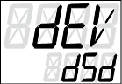
- Restore default value:
  - Press more than 3 seconds, and then you will see 。

2.2 Press and then press , you will see is flashing. Please press to enter the value.
Then the default value is restored.
Service Manual

Troubleshooting Guide
Caution: Always disconnect the power cord before troubleshooting.
Trouble | Cause | Remedy
Instrument inoperative | Power cord not connected to outlet. | Plug instrument in.
Instrument inoperative | Dead power output. | Change to different output.
Instrument inoperative | No fuse Breaker is off | Press the breaker back of the machine, and check if the current is overload.
Instrument inoperative | Electronic element broken | Contact your distributor for repair.
Instrument inoperative | Power switch is broken | Contact your distributor for repair.
Controller can’t control the temperature | Sensor is broken | Contact your distributor for repair.
Controller can’t control the temperature | Controller | Contact your distributor for repair.
Controller can’t control the temperature | Heater is broken | Contact your distributor for repair.
The key of PID controller can’t work | The keys has been locked | Please refer to the other function to release the lock status.
Temperature is not stable | The initial setting value is not suitable for the ambient air temperature where the machine is located | Refer to the other functions, execute the Auto-tuning function.
PV value is not correct | User’s calibration thermometer is different from the factory’s calibration thermometer | Refer to the other functions, execute the function for PV shift (offset) value.

